**Objective:-** Gets two numbers in html page from the user and submit that numbers in jsp page, print appropriate output using methods. (JSP)

**Code :-**

**index.html**

<!DOCTYPE html>  
<html lang="en">  
<head>  
 <meta charset="UTF-8">  
 <title>Experiment - 8</title>  
  
 <!-- Import Poppins Font -->  
 <link href="https://fonts.googleapis.com/css2?family=Poppins:wght@300;400;500;600&display=swap" rel="stylesheet">  
  
 <style>  
 /* General Styling */  
 * {  
 margin: 0;  
 padding: 0;  
 box-sizing: border-box;  
 }  
  
 body {  
 font-family: 'Poppins', sans-serif; /* Applying Poppins font */  
 background: linear-gradient(135deg, #74EBD5, #ACB6E5);  
 min-height: 100vh;  
 display: flex;  
 justify-content: center;  
 align-items: center;  
 }  
  
 .container {  
 background: #ffffff;  
 width: 90%;  
 max-width: 600px;  
 border-radius: 12px;  
 box-shadow: 0 10px 30px rgba(0, 0, 0, 0.2);  
 padding: 30px;  
 text-align: center;  
 transition: 0.3s ease;  
 }  
  
 .container:hover {  
 box-shadow: 0 15px 40px rgba(0, 0, 0, 0.3);  
 }  
  
 h2 {  
 font-size: 30px;  
 color: #333;  
 margin-bottom: 20px;  
 font-weight: 600;  
 }  
  
 form {  
 display: flex;  
 flex-direction: column;  
 gap: 15px;  
 }  
  
 label {  
 font-weight: 500;  
 color: #555;  
 text-align: left;  
 font-size: 16px;  
 }  
  
 input, select, button {  
 width: 100%;  
 padding: 12px;  
 border: 1px solid #ccc;  
 border-radius: 8px;  
 font-size: 16px;  
 transition: 0.3s;  
 font-family: 'Poppins', sans-serif; /* Poppins for form elements */  
 }  
  
 input:focus, select:focus {  
 outline: none;  
 border-color: #4CAF50;  
 box-shadow: 0 0 8px #4CAF50;  
 }  
  
 button {  
 background: #4CAF50;  
 color: white;  
 border: none;  
 cursor: pointer;  
 font-size: 18px;  
 font-weight: 500;  
 transition: 0.3s;  
 }  
  
 button:hover {  
 background: #45a049;  
 }  
  
 .result {  
 margin-top: 20px;  
 padding: 20px;  
 border-radius: 8px;  
 box-shadow: 0 5px 15px rgba(0, 0, 0, 0.1);  
 background: #f4f4f4;  
 transition: 0.3s ease;  
 }  
  
 .result:hover {  
 box-shadow: 0 8px 25px rgba(0, 0, 0, 0.2);  
 }  
  
 .result h3 {  
 color: #333;  
 font-size: 24px;  
 margin-bottom: 10px;  
 font-weight: 500;  
 }  
  
 .result p {  
 font-size: 20px;  
 color: #007BFF;  
 font-weight: 400;  
 }  
  
 .error {  
 color: red;  
 font-weight: bold;  
 }  
  
 /* Responsive Styling */  
 @media (max-width: 768px) {  
 .container {  
 width: 95%;  
 padding: 20px;  
 }  
 }  
 </style>  
</head>  
  
<body>  
  
<div class="container">  
 <h2>Arithmetic Operations</h2>  
  
 <!-- Form for arithmetic operations -->  
 <form method="post" action="calculate.jsp">  
 <label>Enter First Number:</label>  
 <input type="number" name="num1" required>  
  
 <label>Enter Second Number:</label>  
 <input type="number" name="num2" required>  
  
 <button type="submit">Calculate</button>  
 </form>  
</div>  
  
</body>  
</html>

**calculate.jsp**

<%@ page import="java.io.*, java.util.*" %>  
<%@ page contentType="text/html;charset=UTF-8" language="java" %>  
  
<%-- Method declarations should be inside declaration tag --%>  
<%!  
 String compare(int a, int b) {  
 if (a > b) {  
 return "Number 1 is greater than Number 2";  
 } else if (a < b) {  
 return "Number 1 is less than Number 2";  
 } else {  
 return "Number 1 is equal to Number 2";  
 }  
 }  
%>  
  
<%  
 String num1Str = request.getParameter("num1");  
 String num2Str = request.getParameter("num2");  
  
 int num1 = Integer.parseInt(num1Str);  
 int num2 = Integer.parseInt(num2Str);  
  
 String comparisonResult = compare(num1, num2);  
%>  
  
<!DOCTYPE html>  
<html lang="en">  
<head>  
 <meta charset="UTF-8">  
 <title>Experiment - 8 Result</title>  
 <link href="https://fonts.googleapis.com/css2?family=Poppins:wght@300;400;500;600&display=swap" rel="stylesheet">  
 <style>  
 * {  
 margin: 0;  
 padding: 0;  
 box-sizing: border-box;  
 }  
  
 body {  
 font-family: 'Poppins', sans-serif;  
 background: linear-gradient(135deg, #74EBD5, #ACB6E5);  
 min-height: 100vh;  
 display: flex;  
 justify-content: center;  
 align-items: center;  
 }  
  
 .container {  
 background: #ffffff;  
 width: 90%;  
 max-width: 600px;  
 border-radius: 12px;  
 box-shadow: 0 10px 30px rgba(0, 0, 0, 0.2);  
 padding: 30px;  
 text-align: center;  
 transition: 0.3s ease;  
 }  
  
 .container:hover {  
 box-shadow: 0 15px 40px rgba(0, 0, 0, 0.3);  
 }  
  
 h2 {  
 font-size: 30px;  
 color: #333;  
 margin-bottom: 20px;  
 font-weight: 600;  
 }  
  
 .result {  
 margin-top: 20px;  
 padding: 20px;  
 border-radius: 8px;  
 box-shadow: 0 5px 15px rgba(0, 0, 0, 0.1);  
 background: #f4f4f4;  
 transition: 0.3s ease;  
 }  
  
 .result:hover {  
 box-shadow: 0 8px 25px rgba(0, 0, 0, 0.2);  
 }  
  
 .result h3 {  
 color: #333;  
 font-size: 24px;  
 margin-bottom: 10px;  
 font-weight: 500;  
 }  
  
 .result p {  
 font-size: 20px;  
 color: #007BFF;  
 font-weight: 400;  
 }  
  
 @media (max-width: 768px) {  
 .container {  
 width: 95%;  
 padding: 20px;  
 }  
 }  
 </style>  
</head>  
  
<body>  
<div class="container">  
 <h2>Calculation Result</h2>  
 <div class="result">  
 <h3><b>Comparison Outcome</b></h3>  
 <p>Number - 1 : <strong><%= num1 %></strong></p>  
 <p>Number - 2 : <strong><%= num2 %></strong></p>  
 <p>Result: <strong><%= comparisonResult %></strong></p>  
 </div>  
</div>  
</body>  
</html>

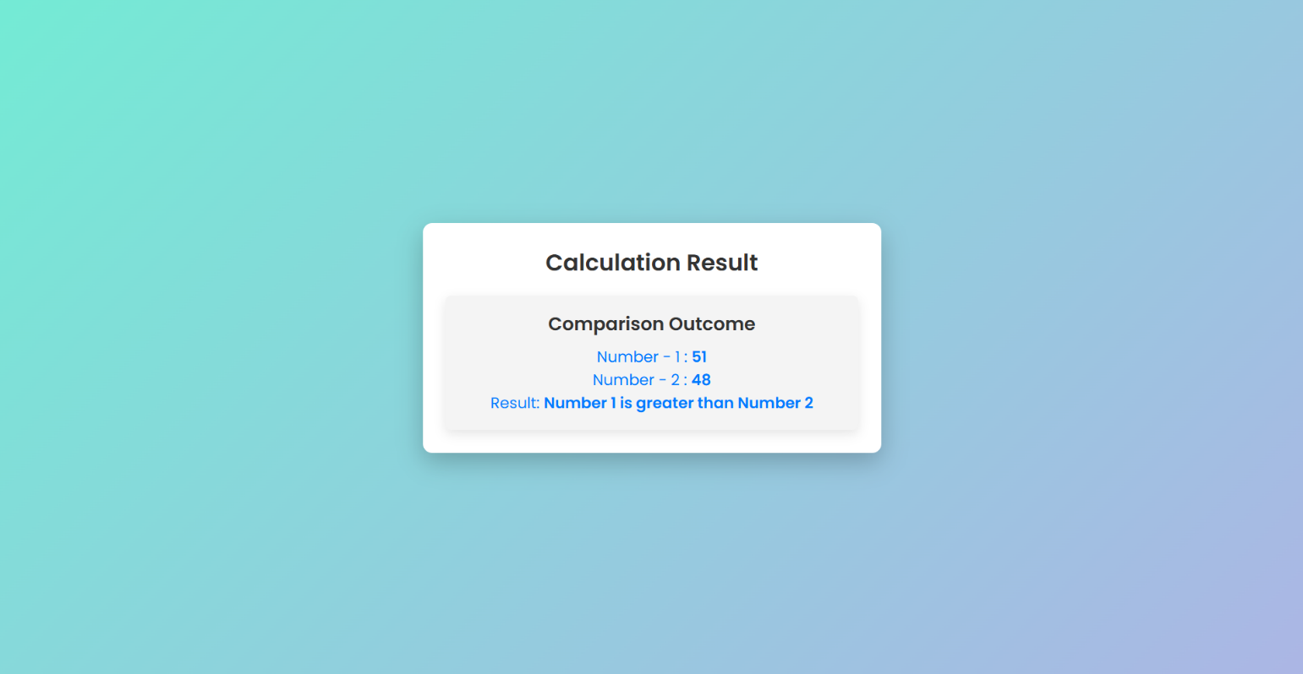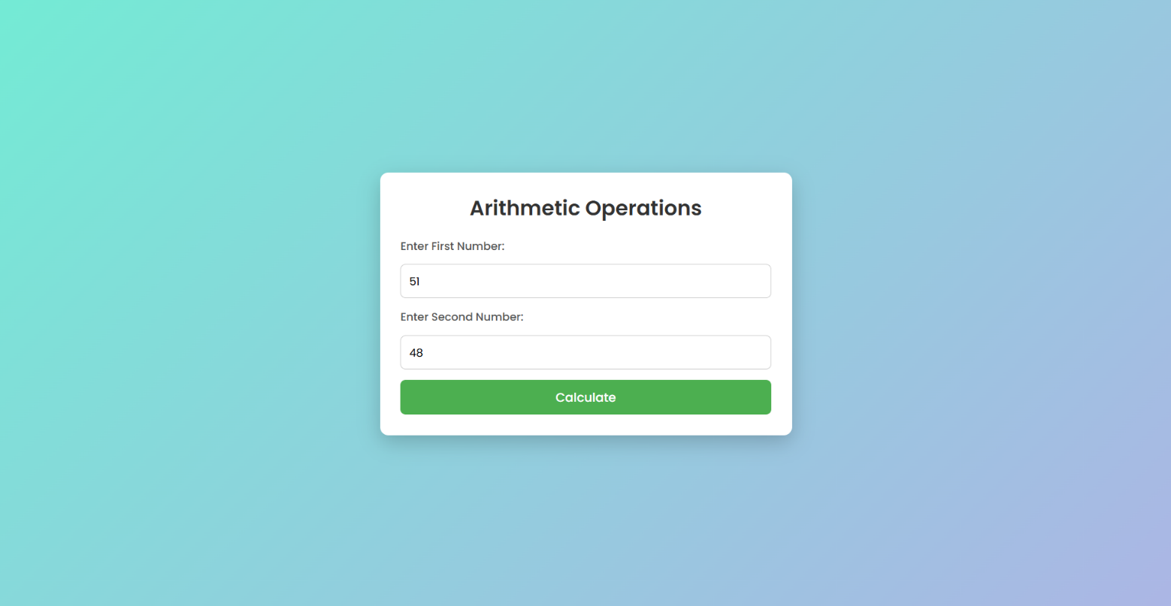**Output:-**